Hot house

This eco-house is kept warm with just one heater.
The heater is turned on and the house has a steady temperature of 21ºC.

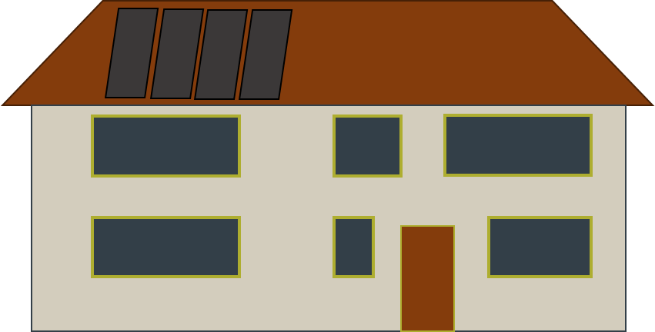

What do you think about each of these statements?
For each statement, tick (✓) one column to show what you think.
Statements |  | I am sure this is right | I think this is right | I think this is wrong | I am sure this is wrong
A | The heater transfers energy into the house by heating.
B | The house transfers energy out through its walls and roof by heating.
C | The house transfers energy by heating at the same rate of as the heater does.

Physics > Big idea PMA: Matter > Topic PMA1: Heating and cooling > Key concept PMA1.2: Heating and cooling
Diagnostic question
Hot house

Overview
Learning focus: | If two objects at different temperatures are in contact, energy will move spontaneously from the object at the higher temperature to the object at the lower temperature.
Observable learning outcome: | Apply the law of conservation of energy to explain what happens to energy in novel situations.
Question type: | Confidence grid
Key words: | Temperature, dissipation, conservation

B | BRIDGING  This diagnostic question probes understanding of ideas that are usually taught at age 14-16, to build a bridge to later stages of learning.

What does the research say?
The conservation of energy is not something that can be conclusively demonstrated to students, but as it is the essential feature of our understanding of energy it must be strongly asserted.
It will make it easier for students to accept the idea of the conservation of energy if it is taught at the same time as the idea of dissipation of energy. Drawing students’ attention to examples of dissipation of energy and encouraging them to identify unintended transfers of energy by heating can help them to reconcile conservation with their everyday experience of energy being ‘lost’. Essentially dissipation identifies what has happened to the ‘missing’ energy. (Fairhurst, 2018)
This question explores students’ understanding of these ideas.
Ways to use this question
Students should complete the confidence grid individually. This could be a pencil and paper exercise, or you could use an electronic ‘voting system’ or mini white boards and the PowerPoint presentation.
If there is a range of answers, you may choose to respond through structured class discussion. Ask one student to explain why they gave the answer they did; ask another student to explain why they agree with them; ask another to explain why they disagree, and so on. This sort of discussion gives students the opportunity to explore their thinking and for you to really understand their learning needs.
Differentiation
You may choose to read the questions to the class, so that everyone can focus on the science. In some situations it may be more appropriate for a teaching assistant to read for one or two students.
Expected answers
All three answers are correct.
How to respond - what next?
When two objects at different temperatures are in contact, heating is the mechanism by which energy will move spontaneously from the object at the higher temperature to the object at the lower temperature. To keep an object at a steady temperature above that of its surroundings, energy has to be supplied to it at the same rate as it is losing energy to its surroundings.
A common misunderstanding is that energy transferred from the heater is ‘used up’ to increase the temperature of the house.
Often students do not examine temperature differences to work out what will happen in a novel situation. As a consequence their predictions are not always scientific. The use of everyday language that describes ‘closing the door to keep the cold out’ may suggest to some that the ‘cold’ outside the house will cancel out the ‘heat’ of the house.
If students have misunderstandings about how to apply the law of conservation of energy to predict what happens in novel situations, it can help to take them through the thinking process outlined above and to make it explicit. Start by noting the temperature of each ‘object’ in contact. Energy will move spontaneously from the object at the higher temperature to the object at the lower temperature. In this example there are two pairs of ‘objects’: the heater and the house; and the house and the outside air. If there is a net flow of energy by heating into or out of an object, then its temperature will increase or decrease.
Giving students further examples to consider can consolidate their learning. This often works best if students work in pairs or small groups, which encourage social construction of new ideas through dialogue.
A suitable example might be to explain how an oven keeps a steady temperature whilst baking a cake. More challenging might be to explain how a freezer keeps ice cream at a steady sub-zero temperature.
Acknowledgments
Developed by Peter Fairhurst (UYSEG).
Images: Peter Fairhurst (UYSEG).
References

